**Formal Contract for PactForPain.com**

**Project Proposal:**

Website + Mobile Apps + Tablet Apps

**Client:**

Dr. James Fricton

**Date Submitted:**

September 25, 2024.

**Submitted by:**

GOIGI

Scope of Work and Evaluation for Website and Web Portal

# 1. Scope of Work

## 1.1 Introduction

This Scope of Work (SOW) document outlines the requirements, objectives, deliverables, and timeline for the development of a Website and Web Portal based on the Seven Realms Training Programs. The portal will serve as a comprehensive platform for managing participants, health coaches, and administrative tasks, with the aim of supporting chronic pain management and health promotion.

## 1.2 Web Portal Requirements

The web portal will serve as a central hub for managing participants, health coaches, and various administrative tasks. The following sections outline the specific requirements and features.

## 1.3 General Overview

## The portal is designed to facilitate the management of health coaching, participant engagement, and tracking of progress in the Seven Realms Training Programs. It includes secure logins, role-based access, and HIPAA compliance.

## 1.4 Project Objectives

The primary objectives of this project are to:

- Develop a secure, HIPAA-compliant web portal with role-based access for Global Admins, Clinic Admins, Health Coaches, and Participants.

- Enable comprehensive participant management, including baseline and progress assessments, online lessons, and tracking of engagement and outcomes

- Provide tools for health coaches to effectively engage with participants and monitor their progress.

* Integrate billing functionalities and data analytics for administrative purposes
* Provide website for marketing and awareness with SEO strategies. (SEO Packages is payable Extra and is not included in the scope of work and pricing)
* Update current pactforpain website with minor changes in the first phase of program.

## 1.5 Deliverables

The following deliverables are expected from this project:

- Fully functional web portal with defined user roles and permissions.

- Customizable dashboard for participant and clinic management.

- Integrated online lessons and printable resources for the Seven Realms Training Programs.

- Notifications and reminder system for participant engagement.

- Billing system integrated with CPT codes and documentation.

- Data of participant assessment with analytics and reporting tools for administrative users.

* A mobile app interface that integrates with the web portal
* As part of the process, update current pactforpain platform with minor changes in the first phase of program including adding the ability of participants to pay for the access of the platform.

## 1.6 Functional Requirements

### 1.6.1 *User Roles and Permissions (Hypothetical Numbers)*

The portal will include multiple user roles with specific permissions, including Global Admins, Clinic Admins, Health Coaches, and Participants.

Each role will have access to specific functionalities relevant to their responsibilities.

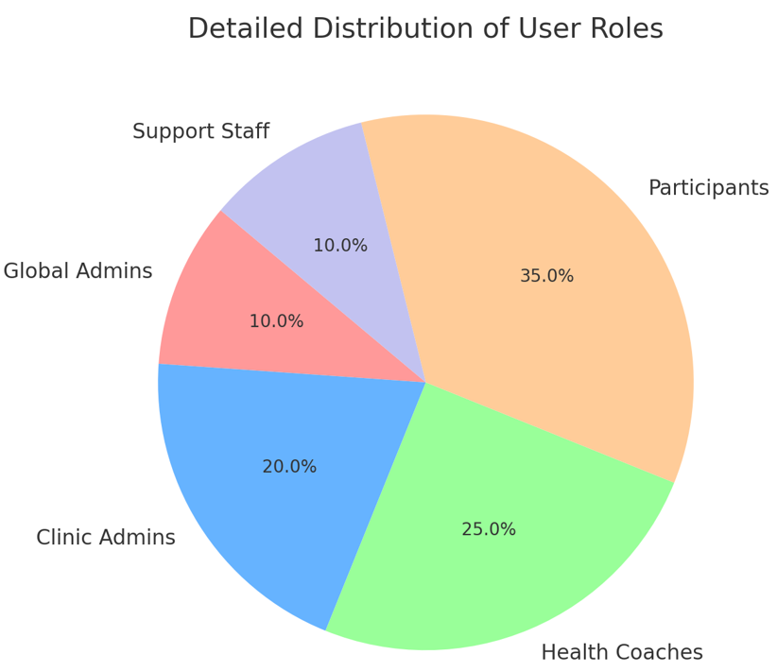

### 1.6.2 *Platform Features*

- **Participant Management**: Baseline and progress assessments, participant engagement tracking, and personalized dashboards.

- **Online Lessons**: Educational content for the Seven Realms, accessible by participants and health coaches.

- **Notifications and Reminders**: Email and text alerts for assessments, lessons, and action plans.

## - **Billing and Administration**: Tools for users to pay for access with a credit card, generating billing codes, tracking payments, and managing clinics.

## 1.7 *Technology Stack*

The platform will be built using the following technologies:

- \*\***Hosting**\*\*: Amazon EC2 with Linux OS and Tomcat web server.

- \*\***Web Development**\*\*: Java/Spring Framework, Angular, jQuery, CSS3, and HTML5.

- \*\***Security**\*\*: Role-based access using Spring Framework and SSL for secure communication.

- \*\***Build Tool**\*\*: Maven.

- \*\***Database**\*\*: MySQL (RDS) with data analytics powered by Lucene and Angular JS.

- \*\***Mobile Integration**\*\*: REST-based services with JSON response for seamless mobile app integration including the ability to download a mobile app.

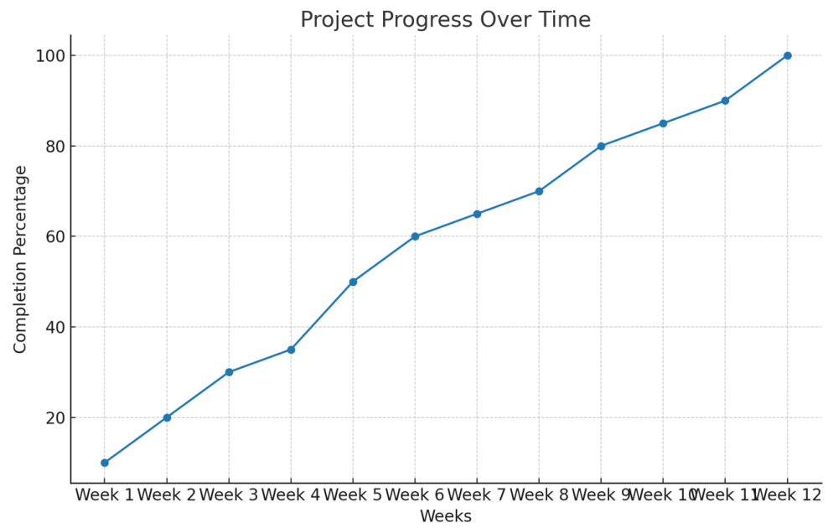

## 1.8 *Assumptions and Dependencies*

The following assumptions and dependencies are considered in the scope of this project:

- All required content and resources for the Seven Realms Training Programs will be provided by the client.

- The platform will be deployed and updated on the client's existing Amazon Web Services (AWS) infrastructure and then transferred to the VPS server.

- Any third-party integrations or APIs will be provided and maintained by the client.

# 2. Evaluation Plan

## 2.1 *Evaluation Objectives*

The evaluation plan aims to ensure that the website and web portal meet the specified requirements and perform effectively across all functionalities. The evaluation will focus on usability, performance, security, and scalability.

## 2.2 *Key Performance Indicators (KPIs).*

The following KPIs will be used to evaluate the success of the project:

- **Usability**: User satisfaction scores and task completion rates.

- **Performance**: Page load times, system uptime, and responsiveness under load.

- **Security**: Compliance with HIPAA standards, SSL certification, and penetration test results.

- **Scalability**: Ability to handle increased user load and data volume without performance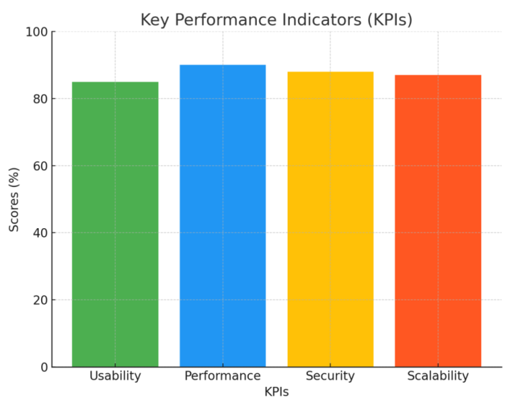 degradation.

## 2.3 *Evaluation Methodology*

The evaluation will be conducted through a combination of automated testing, user feedback sessions, and performance monitoring. The methodology will include:

- **User Testing**: Conducted with a sample group of users from each role (Admins, Coaches, and Participants).

- **Automated Testing**: Using tools like JMeter for performance testing and TestNG for unit testing.

- **Security Testing**: Regular vulnerability assessments and penetration testing.

## 2.4 *Testing and Quality Assurance*

A dedicated testing and QA phase will be carried out to ensure that the platform meets all functional and non-functional requirements. The QA process will include:

- **Functional Testing**: Verification of all user roles and features.

- **Performance Testing**: Load and stress testing to ensure scalability.

- **Security Testing**: Compliance with HIPAA and industry standards.

- **User Acceptance Testing (UAT)**: Final approval by the client before deployment.

## 2.5 *Reporting and Feedback (Depends based on the requirements)*

Regular reports will be generated during the evaluation process to keep stakeholders and developers informed of progress and issues. Feedback from users will be collected and analyzed to inform any necessary adjustments.

## 2.6 *Success Criteria (Hypothetical Scenario)*

The project will be considered successful if it meets the following criteria:

- The platform is delivered on time and within budget.

- All functional and non-functional requirements are met.

* The platform receives positive feedback from users and stakeholders with all errors corrected.

- The platform demonstrates stability, security, error-free, and scalability in a live environment.

Scope of Work (SOW) and Evaluation for PACT Mobile Application Development

# 1. Project Overview

It includes development of a mobile application for Android and iOS platforms that integrates with the existing PACT web platform. The mobile app will include features for Global Admins, Clinic Admins, Health Coaches, and Participants. The app must be HIPAA compliant and support a hierarchy of permissions.

# 2. Objectives

- To provide a mobile interface for PACT's Seven Realms Training Programs now called the Pain Prevention Program.  
- Ensure secure login and role-based access in compliance with HIPAA regulations.  
- Integrate the downloadable mobile app with the existing web platform, ensuring seamless data synchronization.  
- Provide users with functionalities including assessments, progress tracking, online lessons, reminders, and billing.

# 2.1. Workflow Phases (Total estimated to be 28 weeks (7 months)

### 1. Requirements Gathering & Finalization (2 weeks)

* Collect and finalize all project requirements by engaging with stakeholders including review of the current functionality in the existing [pactforpain.com](http://pactforpain.com) platform and updating errors to ensure they are avoided in the next version
* This would include ability to have users pay for 6 months access with credit card and extension of access for additional 6 month periods on the existing [pactforpain.com](http://pactforpain.com) site.

### 2. UI/UX Design (4 weeks)

* Design and refine the user interface and experience, ensuring stakeholder approval reviewing changes needed to the current platform.

### 3. Development (12 weeks)

* Develop the mobile applications for both Android and iOS platforms using Kotlin/Java and Swift/Objective-C, with a preference for React Native for cross-platform development.
* Integrate existing data from current database, backend services and ensure security compliance.

### 4. Testing & QA (4 weeks)

* Conduct thorough testing, including unit and load testing, bug fixes, and security assessments to ensure the app meets all requirements.

### 5. Deployment & Training (2 weeks)

* Deploy the application to cloud services and app stores, and provide training to users.

### 6. Post-launch Support (4 weeks)

* Monitor the app post-launch, providing bug fixes, minor updates, and ongoing support.
* Include articles and information to increase SEO as part of the initial website development
* 6 months of free maintenance including correcting errors and updating public website to drive access with SEO content

Each phase is designed to ensure the project progresses smoothly from initial planning to post-launch support, focusing on key milestones and stakeholder involvement.

# 3. Key Deliverables

- Mobile App for Android and iOS: A fully functional mobile app that mirrors the functionalities of the PACT web platform.  
- User Authentication & Role-Based Access Control:  
 - Secure login with hierarchical permissions.  
 - Support for Global Admin, Clinic Admin, Health Coaches, and Participant roles.  
- Assessments:  
 - Baseline and progress assessments for participants wtih downloadable reports  
 - Monthly progress tracking and reporting   
- Dashboard:  
 - Participant engagement summary.  
 - Progress tracking over time with tables and figures  
- Online Lessons:  
 - Access to Seven Realms lessons and other educational content.  
 - Support for video, text, quizzes, and downloadable resources.  
- Reminders & Notifications:  
 - Automated reminders for participants regarding action plans and assessments.  
- Billing Module:  
 - Integration for generating CPT codes and documentation for completed assessments including payments of participants using credit cards with direct payment to banks.   
- Administrative Views:  
 - Tools for managing participants, coaches, and clinics.  
 - Data analytics and reporting capabilities.  
- Content Management   
 - Ability to add, modify, or delete lessons, assessments, and resources

- Ability to replicate entire site and content with website for different populations including adolescents and seniors.

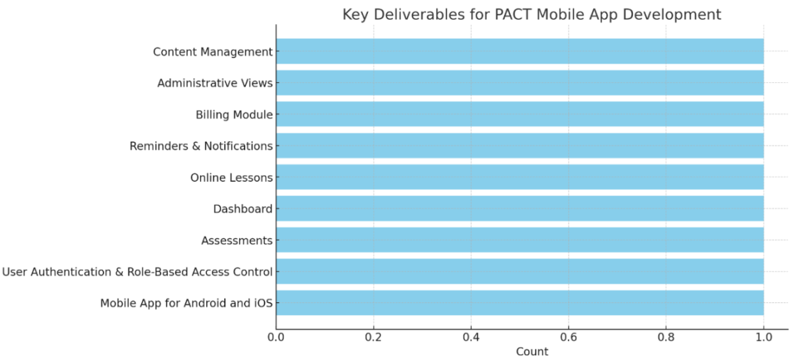

# 4. Technology Stack

- **Mobile Development:**  
 - Android: Kotlin/Java  
 - iOS: Swift/Objective-C

-React Native (For Android & IOS) – **Preferable.**

- **Backend Integration:**  
 - RESTful APIs  
 - JSON for data exchange

- **Security:**  
 - SSL for secure data transmission.  
 - Spring Framework for role-based access control.

- **Database:**  
 - MySQL (via Amazon RDS)  
 - Amazon EC2 for hosting the backend services.

- **Testing:**  
 - JMeter for load testing.  
 - TestNG for unit testing.

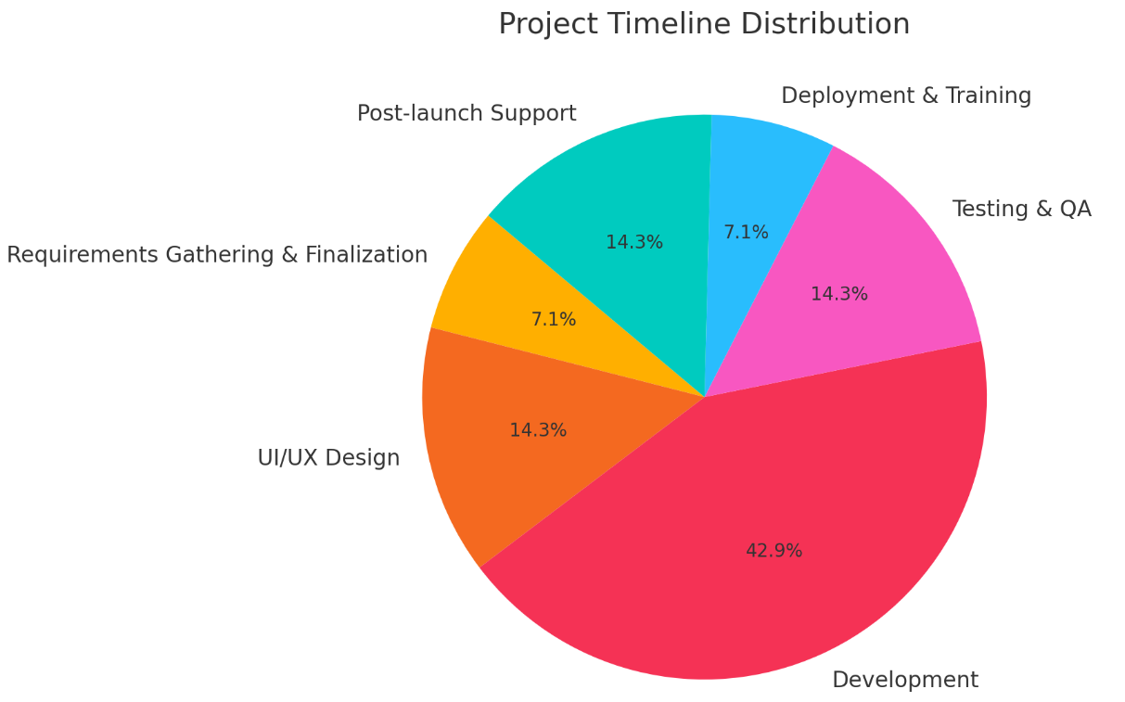

# 5. Evaluation Criteria

- Functionality: The app must meet all functional requirements as outlined in the SOW, including secure login, assessments, progress tracking, and lesson delivery.  
- Performance: The app should load within 3 seconds, with seamless transitions between screens. It should handle concurrent user sessions without lag.  
- Security: The app must comply with HIPAA regulations, ensuring secure data handling and storage.  
- User Experience: The UI/UX should be intuitive, with clear navigation and responsive design. The app should be easy to use for all user roles (Admin, Coaches, and Participants).  
- Integration: The app should integrate seamlessly with the existing PACT web platform, ensuring data consistency across platforms.  
- Testing & Bug Resolution: All identified bugs during the testing phase must be resolved before deployment.  
- Post-launch Support: The vendor must provide post-launch support for bug fixes and minor updates for at least 4 weeks.

# 6. Assumptions

- The client will provide all necessary access to the existing web platform and databases.  
- Any third-party services (e.g., for notifications, video hosting) required will be provided by the client.  
- The mobile app will adhere to the design guidelines provided by the client.

# 7. Dependencies

- Finalization of requirements by the client.  
- Timely feedback on UI/UX designs.  
- Availability of the backend APIs for integration.

# 8. Acceptance Criteria

- The mobile app must pass all functional, performance, and security tests.  
- The app must be approved by the client after the User Acceptance Testing (UAT) phase.  
- The app must be successfully deployed on Google Play Store and Apple App Store.

Development of Android Tablet, iPad and Mobile Application for [PactforPain.com](http://PactforPain.com) and www.painpreventionprogram.com

## 1. Project Overview

PactforPain.com provides the Personalized Activated Care & Training (PACT) platform, which offers the Seven Realms Training Programs. These programs are designed to prevent pain and promote health through various tools and techniques. The objective of this project is to develop a user-friendly, responsive, and secure mobile application for Android Tablets and iPads that mirrors the functionalities of the existing web platform.

## 2. Objectives

- Development of Mobile Application: Create a mobile application for Android Tablets and iPads that replicates the existing web functionalities.

- User Experience: Ensure a seamless user experience with intuitive navigation and easy access to all features.

- HIPAA Compliance: Maintain the highest level of security, including HIPAA compliance, for the protection of user data.

- Customization and Flexibility: Allow for customization and scalability to adapt to future updates and enhancements.

## 3. Key Features

The application will include updating the current website with minor errors and ability to bill and then include the following key features in the new website:

3.1 User Authentication and Access  
- Secure login with multi-tiered access levels for Global Admins, Clinic Admins, Providers/Health Coaches, and Clients/Patients.  
- Password recovery and profile management.  
- Role-based access control to ensure data privacy and security.

3.2 Dashboard  
- Display participant summaries, engagement levels, and progress over time.  
- Access to action plans and progress reports.

3.3 Assessments  
- Baseline and progress assessments with reports for each of the seven realms: Body, Lifestyle, Mind, Emotion, Spirit, Social, and Environment.  
- Monthly progress assessments with graphical data outputs.

3.4 Online Lessons  
- Access to the Seven Realms online lessons, with video content, documents, and quizzes.  
- Lessons will be available in a mobile-optimized format, with shorter videos and closed captions.

3.5 Notifications and Reminders  
- Automated text or email reminders for participants to complete action plans and assessments.  
- Notifications linked to relevant programs on the app.

3.6 Billing and Administrative Tools  
- Billing module to generate visit assessments, CPT codes, and documentation.  
- Administrative views for global, health group, and clinic admins.  
- Data analytics for tracking participant progress and engagement.

3.7 Resource Management  
- Access to printable resources, including handouts and monitoring tools.  
- Option to add or modify resources as needed.

3.8 Health Coach and Participant Interaction  
- Health Coaches can monitor participant engagement and send reminders.  
- Integration of bios and credentials for Health Coaches.

## 4. Technology Stack

The following technologies will be used for the development of the mobile application:

- Frontend: Angular, JQuery, CSS3, HTML5 (adapted for mobile platforms).  
- Backend: Java/Spring Framework, REST-based services with JSON responses.  
- Database: MySQL (as part of Amazon RDS).  
- Hosting: Amazon EC2 instances with Tomcat Webserver.  
- Security: Role-based security through the Spring framework, Startcom SSL, HIPAA compliance features.  
- Mobile Integration: REST services, JSON response, integration with existing Klara app functionalities.

The development of Android tablets and iPads involves specific technologies and platforms tailored to their respective ecosystems:

**Android Tablets:**

Operating System: Android OS, which is based on the Linux kernel.

Programming Languages: Java and Kotlin are primarily used for Android app development.

**Development Tools:**

Android Studio: The official integrated development environment (IDE) for Android development.

Gradle: Build automation tool used in Android Studio.

**APIs and Frameworks:**

Android SDK: Software development kit that provides the necessary tools and APIs to build Android apps.

Jetpack: A set of Android software libraries that help with managing UI components, data persistence, and more.

Firebase: Provides backend services like analytics, database, messaging, and crash reporting.

**UI/UX Design:**

Material Design: Design language developed by Google that emphasizes grid-based layouts, responsive animations, and transitions.

XML: Used to define UI layouts and elements.

**iPads:**

Operating System: iOS/iPadOS, which is based on Darwin (BSD) and NextStep (Unix).

Programming Languages: Swift or Objective-C.

**Development Tools:**

Xcode: The official IDE for iOS/macOS development.

Cocoa Touch: A UI framework for building software programs to run on iOS.

**APIs and Frameworks:**

UIKit: Framework for constructing and managing the graphical, event-driven user interface in iOS applications.

Core Data: Framework for managing object graphs and data persistence.

CloudKit: Provides cloud storage and syncing capabilities.

**UI/UX Design:**

Human Interface Guidelines: Apple's design principles that guide the creation of iOS/iPadOS applications.

Storyboard/XIB: Interface Builder tool for designing UI components visually in Xcode.

Both platforms also emphasize secure coding practices and incorporate specific security technologies like encryption, secure boot, and application sandboxing to ensure the safety of users' data and devices. The requirements related to PACT seems to leverage a variety of these technologies for mobile app integration, particularly using REST-based services and JSON for Android and other responsive web technologies, which could be relevant for both Android and iPad platforms​.

## 5. Development Process

5.1 Design Phase  
- Create wireframes and UI/UX designs for the Android and iPad applications.  
- Design review and approval by the client.

5.2 Development Phase  
- Backend integration.  
- Frontend development and optimization for mobile platforms.  
- Implementation of key features as outlined in the SOW.

5.3 Testing Phase  
- Conduct thorough testing to ensure all features work seamlessly on both Android Tablets and iPads.  
- Ensure the application meets HIPAA compliance and security standards.  
- User Acceptance Testing (UAT) with feedback incorporation.

5.4 Deployment and Launch  
- Deploy the mobile applications to Google Play Store and Apple App Store.  
- Post-launch support and maintenance.

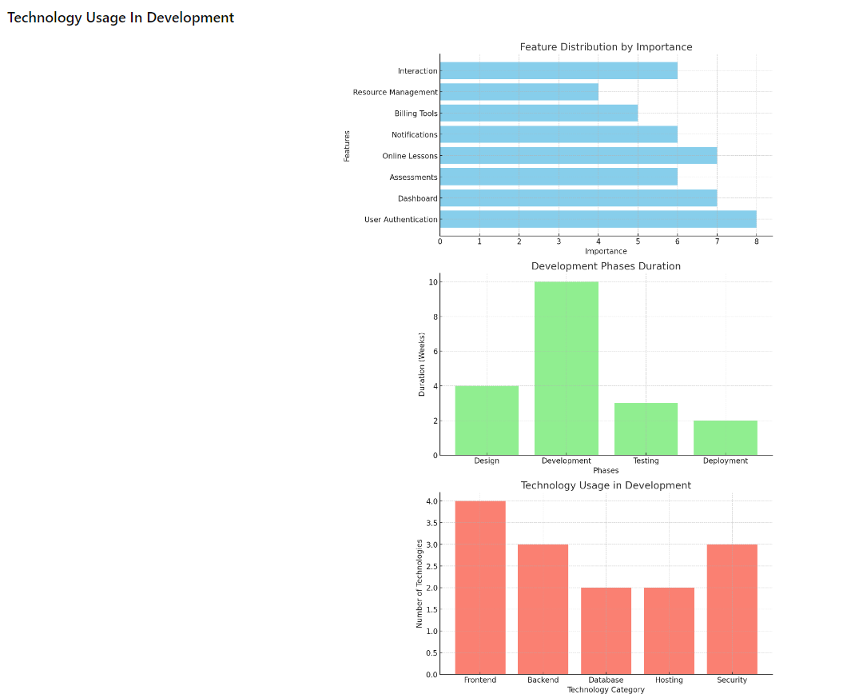

Here are the bar charts representing the data from the document:

1. **Feature Distribution by Importance**: This chart shows the relative importance of each feature in the application.
2. **Development Phases Duration**: This chart illustrates the duration (in weeks) allocated to each phase of the development process.
3. **Technology Usage in Development**: This chart displays the number of technologies used in different categories (Frontend, Backend, etc.).

## 6. Timeline

The project will be completed within 8-10 weeks, with key milestones as follows:  
- Design Phase: 1-2 weeks  
- Development Phase: 4-6 weeks  
- Testing Phase: 1 week  
- Deployment: 2 weeks

## 7. Deliverables

- Fully functional Android Tablet and iPad applications.  
- Source code and documentation.  
- User manuals and training sessions.  
- Post-launch maintenance and support.

## 8. Assumptions and Dependencies

- The existing web platform functionalities and backend services are stable and accessible.  
- Timely feedback and approval from the client at key milestones.  
- Availability of all required resources, including content for the lessons and assessments.

## 9. Terms and Conditions

- Any changes in the scope of work may result in additional costs and timeline adjustments.  
- Regular progress updates will be provided to ensure alignment with project goals.  
- Confidentiality and data security measures will be strictly adhered to as per HIPAA guidelines.

## Evaluation

An evaluation of the performance and functionality of the Android Tablet and iPad application will be conducted based on the following criteria:

1. **User Interface and Experience: ** Ease of use, intuitiveness, and visual appeal.  
2. **Functionality: ** all key features as outlined in the SOW must be fully functional.  
3. **Performance: ** Application responsiveness and load times.  
4. **Security: ** Adherence to HIPAA compliance and data protection measures.  
5. **Stability: ** Absence of bugs and crashes during testing and initial use.  
6. **Client Satisfaction: ** Feedback from the client regarding the application’s alignment with the initial objectives.

## Evaluation Metrics

- **User Feedback: ** Collect feedback from beta testers and the client.  
- **Performance Testing: ** Conduct load and stress tests to evaluate the application’s performance under different conditions.  
- **Security Audit: ** Perform a security audit to ensure compliance with HIPAA standards.  
- **Bug Tracking: ** Monitor and resolve any issues reported during testing.

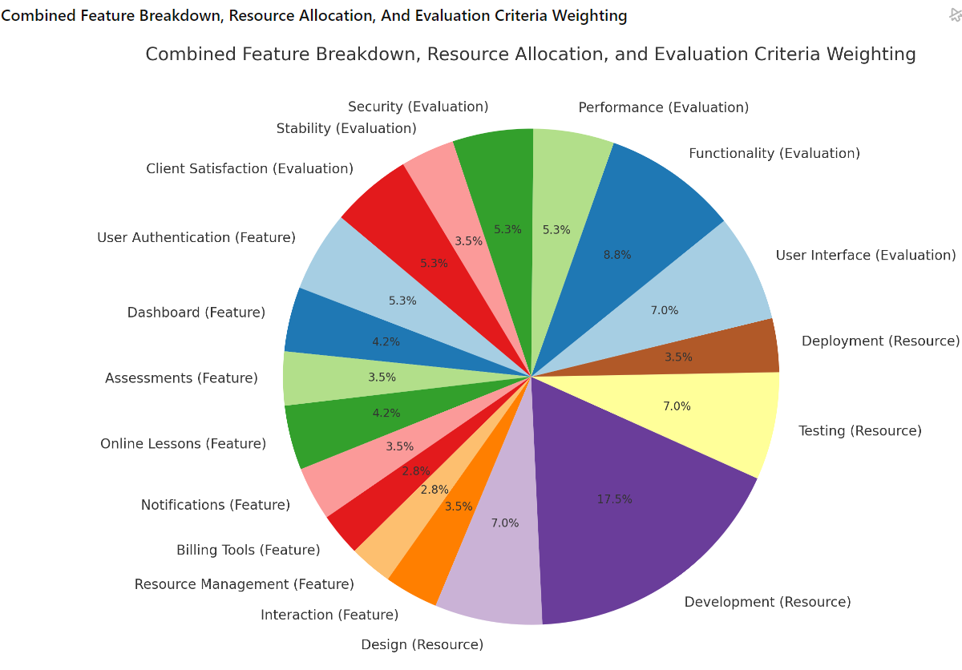

Here is the combined pie chart that represents the **Feature Breakdown**, **Resource Allocation**, and **Evaluation Criteria Weighting** all in one chart. Each section is labelled according to its category (Feature, Resource, or Evaluation) to provide a comprehensive view of how different aspects of the project are distributed.

This chart can help in visualizing the overall balance and focus areas of the project.

**Key specifications for the prevention program:**  
  
**Web and Mobile Platform Access Levels:**

* SRS Admin: Administers the entire platform.
* Clinics with Providers: Can enroll and manage patients.
* Patients: Access the program's assessments and resources and bill through the website.

**Core Features:**

* Public-Facing Website: Adaptable public website page to generate high SEO with articles and testimonies about the prevention program.
* Admin Features: Ability to add clinics, participants, track patient numbers, and handle billing.
* Clinic Providers: both Coach-Enroll and self-enroll patients, send program details, and manage assessments.
* Patient Assessments: Baseline and follow-up assessments, modifiable by Admin, with reports generated for review by providers.
* Patient Progress Tracking: Weekly or monthly progress reports via email/text reminders.
* Video Content Management: Providers can send videos to patients, with Admins controlling updates, additions, or deletions.
* Data Management: Centralized database for videos, assessments, and patient data, modifiable by Admin.
* Outcome Evaluation: Admins can aggregate and analyze clinic-wide data to evaluate program outcomes.

**Client to provid as when requested by Team GOIGI:**

**1. Payment Gateway Details such as Stripe or PayPal**

**2. Google Android PlayStore Login Credentials**

**3. IOS Itunes App Store Login Credentials**

**Thanking You**